Database systems

Lab 2

Hassaan Akbar Cheema

174351

# Lab Task

1. Re Write SQL expressions for each of the following queries and execute them:
2. Create a database for these four relations. You need to define the primary keys and foreign keys in your statement. After creating the database, evolve it as follows.
3. Add a new attribute age in STUDENT table. .
4. Modify data type of attribute: NAME (i.e. cname, sname, fname) in all tables to varchar data type.
5. Add a new NOT NULL constraint to DEPTID in FACULTY table.
6. After creating the database using your SQL statements, populate the database according to the data given in text files using the SQL

ANS 1-5

Code:

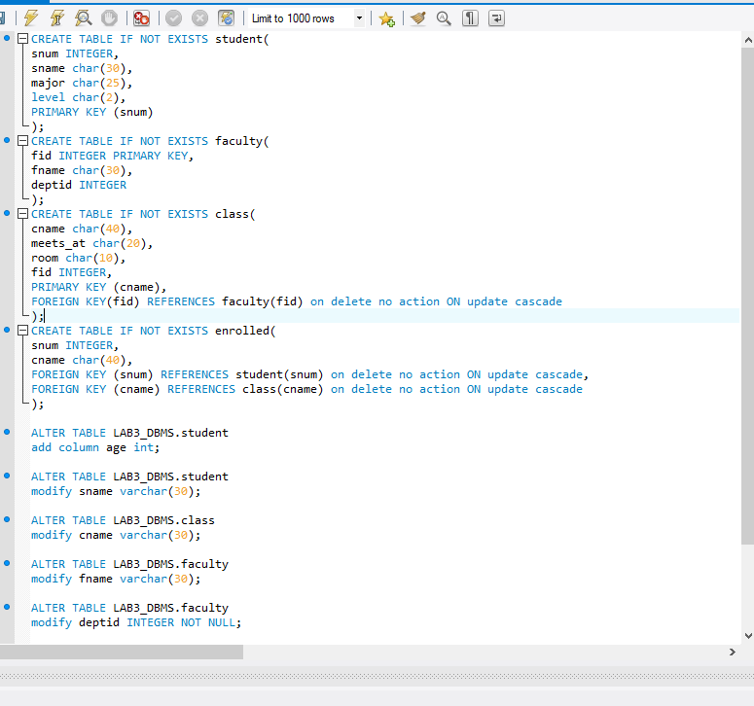

ANS 6

DATA ENTERY:

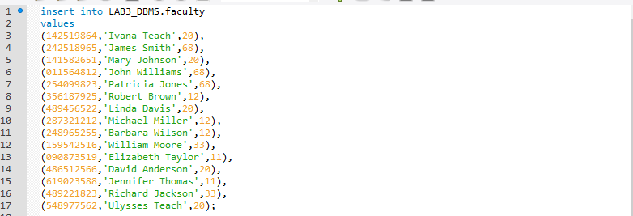

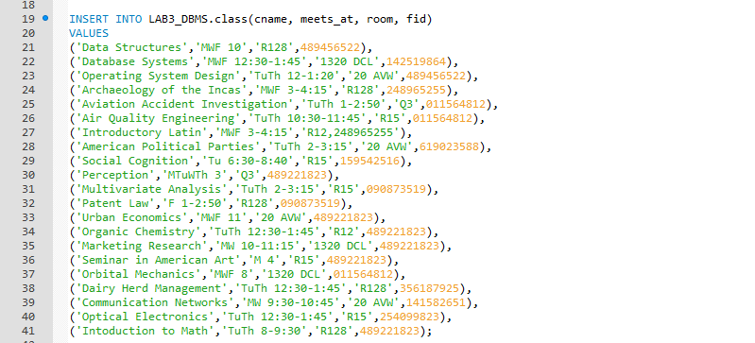

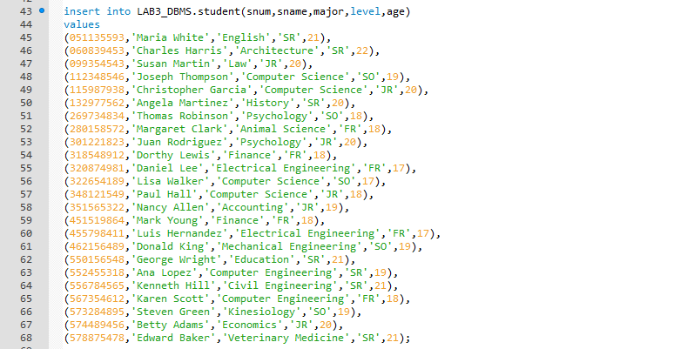

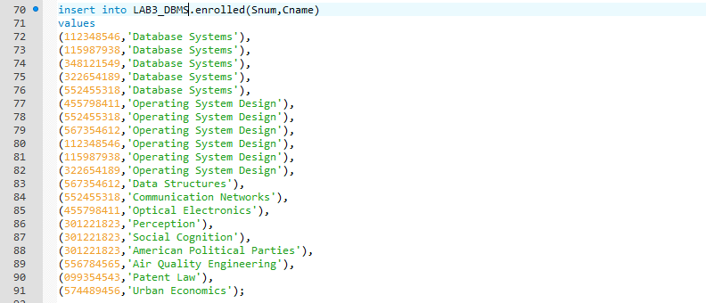

RESULT:

ENROLLED:

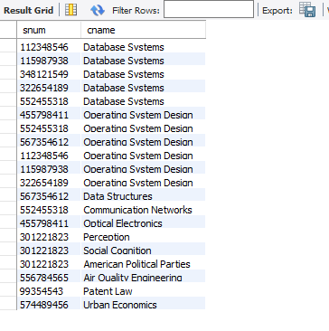

FACULTY:

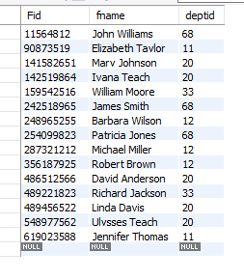

STUDENT:

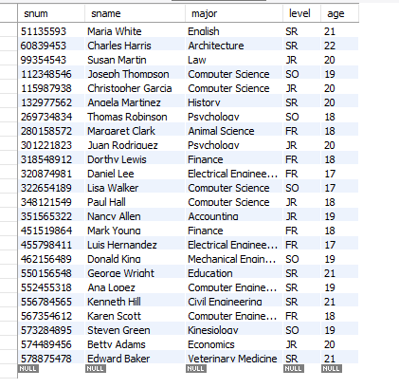

CLASS:

